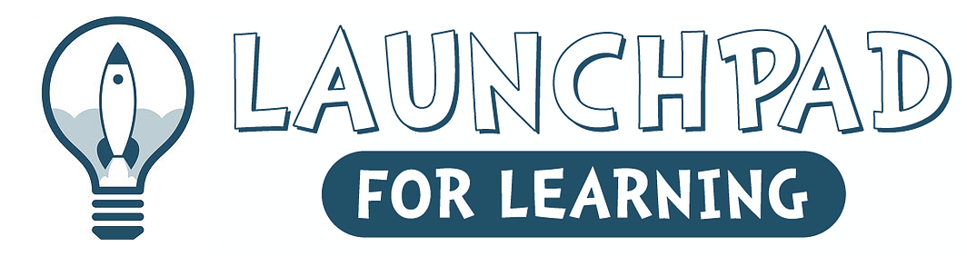
9400 Transit Road - East Amherst, New York 14051 716-688-1772
WWW.LAUNCHPADFORLEARNING.COM
monica@launchpadforlearning.com

Registration Application for SUMMER CAMP 2024

Child’s Name ______________________________________Telephone # (____) ________________

Date of Birth______________________ Age in September ___________ Sex: Male Female

Street Address_______________________________________________________________________

Town_______________________________________ Zip Code_______________________________

E-Mail Address – Required_____________________________________________________
Please PRINT Clearly

Mother’s Name / Guardian_____________________________ Home # (____) __________________

Address _____________________________________________________________________________

Place of Employment ________________________________Work # (____) _____________________

Occupation ________________________________________ Cell # (___) _______________________

Father’s Name / Guardian_____________________________ Home # (____) ___________________

Address_____________________________________________________________________________

Place of Employment _______________________________ Work # (____) ______________________

Occupation _______________________________________ Cell # (____) _______________________

If parents cannot be reached, we will contact the person below:

Emergency Name _____________________________________________________________________

Relationship to Child __________________________________________________________________

Telephone #’s (____) _______________________ (____) _____________________________________

Does Your Child Have Any Allergies Or Physical Limitations? __________________________________

If Yes, Please Explain in detail ____________________________________________________________

NAME:_____________________________________ AGE:______________

Summer Camp will be held during the weeks listed below
for children between the ages of 3 years old – 7 years old

Camp runs from 9AM-12PM

Call for additional details on our specific programs and to schedule a tour if you’d like to see our beautiful facility!

Tuition:

Monday – Friday
$150 weekly

Please circle the sessions you plan to attend

 | July 8TH | M,T,W,T,F AM Jurassic Park week
 | July 15TH | M,T,W,T,F AM Princess and super hero week
 | July 22nd | M,T,W,T,F AM Mad Science and Space Week
 | July 29th | M,T,W,T,F AM Water week/ocean week
 | August 5th | M,T,W,T,F AM Pirates and Mermaids week
 | August 12th | M,T,W,T,F AM Arts and crafts Week
A non-refundable $200.00 Registration fee is required with this completed application to hold a space for your child in a camp or on a waiting list. The registration fee will be applied towards balance of camp.
Please bring water bottle with you daily.

Refer to launchpadforlearning.com for specific weekly themes!
A minimum of six children is required or classes may be cancelled

