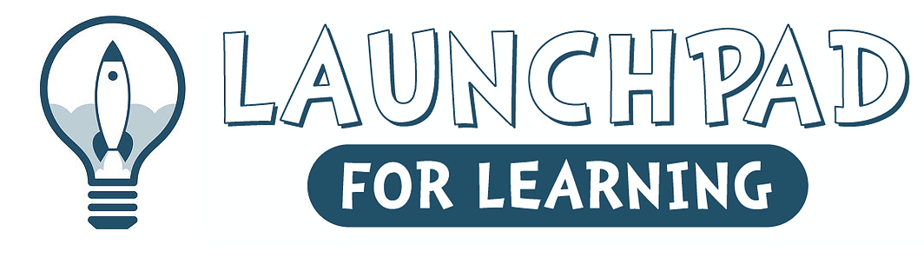
9400 Transit Road - East Amherst, New York 14051
716- 688-1772
www.launchpadforlearning.com

Registration Application for 2023-2024 School Year

Child’s Name ______________________________________Telephone # (____) ________________

Date of Birth______________________ Age in September ___________ Sex: Male Female

Street Address_______________________________________________________________________

Town_______________________________________ Zip Code_______________________________

E-Mail Address – Required_____________________________________________________
Please PRINT Clearly

Mother’s Name / Guardian_____________________________ Home # (____) __________________

Address _____________________________________________________________________________

Place of Employment ________________________________Work # (____) _____________________

Occupation ________________________________________ Cell # (___) _______________________

Father’s Name / Guardian_____________________________ Home # (____) ___________________

Address_____________________________________________________________________________

Place of Employment _______________________________ Work # (____) ______________________

Occupation _______________________________________ Cell # (____) _______________________

If parents cannot be reached, we will contact the person below:

Emergency Name _____________________________________________________________________

Relationship to Child __________________________________________________________________

Telephone #’s (____) _______________________ (____) _____________________________________

Does Your Child Have Any Allergies Or Physical Limitations? __________________________________

If Yes, Please Explain in detail ____________________________________________________________

Names of Children/Others Living in the Household (include age of children)
_____________________ ______________________ ______________________

What school district do you reside in? _____________________________

Does your child currently attend a preschool program? Yes – where? ___________________ No
Programs
3-year-old program:

Monday - Friday

________1:30pm-4:00pm…………………………………………………..Tuition per year $3700.00
9 monthly payments:after initial $400.00 down payment due no later than August 1st……$370.00

4-Year-Old Preschool Program:

Monday - Friday

______1:30pm – 4:00pm..................................................Tuition per year $3700.00
9 Monthly Payments: after initial $400 down payment due no later than August 1st ...$370.00 per month

All programs must have at least 7 children or classes could be canceled
A $85.00 Registration fee is required with this completed application to hold a space for your child in a class or on a waiting list. The registration and initial deposit are non-refundable.
Tuition for the programs listed above may be paid as follows:
- Option 1 – One payment
Full Tuition Due No Later Than August 1st
- Option 2 - Two Equal Installments
1st installment Due No Later than August 1st
2nd installment Due No Later than December 1st
- Option 3 - Installment Plan:
If you select this option for paying tuition, Launchpad for Learning has added a $5.00 installment fee to each payment after the down payment is made.
Installments are due on the dates listed below:
Sept 1st, Oct. 1st, Nov. 1st, Dec. 1st, Jan. 1st, Feb.1st, Mar.1st, Apr. 1st, May 1st
Late fee will be added for payments made after the 3rd of each month (35.00)
Please Make All Checks Or Money Orders Payable To: Launchpad for Learning LLC
Parent/Legal Guardian Signature_______________________________ Date____________
Please note:
- A minimum enrollment of six (7) children per session is required by September 1st or class can be cancelled
- Registration fee and down payment are non-refundable.
- Classes and times subject to change
- If your child has an ALLERGY, parents must notify the teachers via the Child Questionnaire

