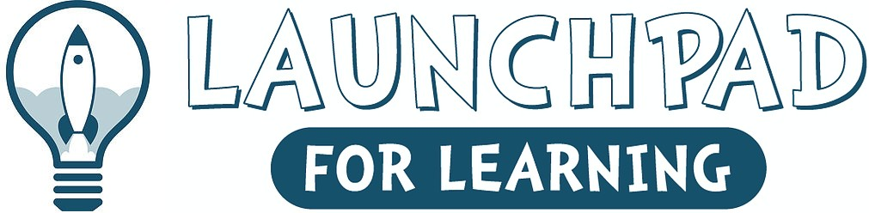

Launchpad for Learning
Supply List 2023-2024

6 - Large Elmer's Glue Sticks
2-Box of colored pencils-sharpened

12- Sharpened pencils
2- Composition notebook – with name labeled red and black
- -scissors
2-– vinyl pocket folders with prongs red or blue
2- 24 packs of Crayola crayons
- Containers of Play-Doh -any color
2- Kleenex boxes
2- rolls of scotch tape
2 - Rolls of paper towels
- Box of gallon Ziploc bags
- Box quart size Ziploc bags
2 - Clorox/Lysol wipes
4- Black sharpie markers
- Package paper plates
2- Boxes of Crayola markers
6- Black dry erase markers
-Complete set of extra clothes (please label)
-Full size backpack and water bottle with child’s name. This will be brought to and from school each day.
-$15 Activity and Supply Fee
We look forward to working with your child during the upcoming school year. In September, your child will need the following school supplies.

